Voting Locations
Election Precinct Location Address
001 Sierra Blanca Methodist Ranch Road 111
Sierra Blanca, Tx 79851

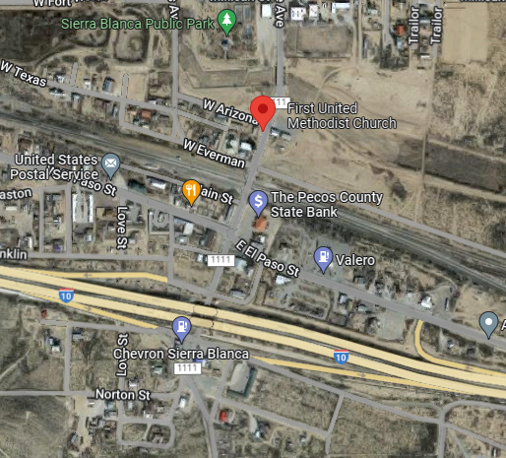

01W Hudspeth County Conservation 71920 Texas Highway 20
And Reclamation District #1 Fort Hancock, Tx 79839

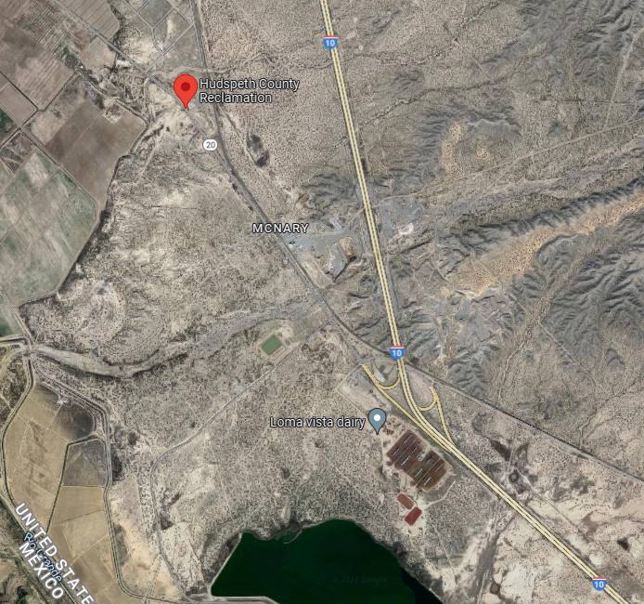

002 Fort Hancock Community Center 1044 Knox Ave.
Fort Hancock, Tx. 79839

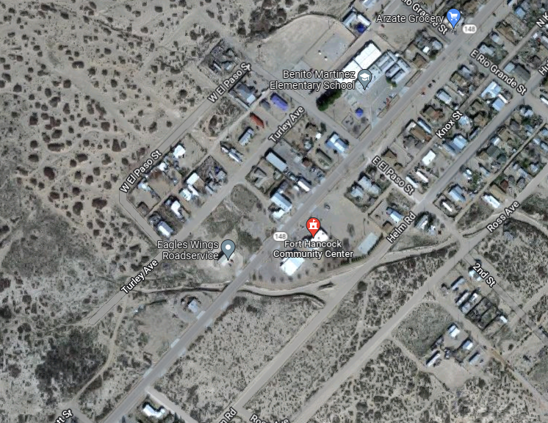

03N Desert Haven Fire Station 5541 US 62
El Paso, Tx. 79938

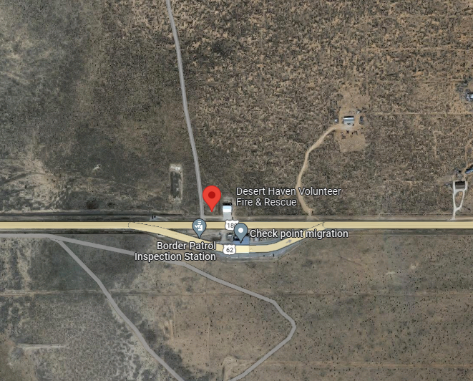
O3S Hudspeth County Municipal Bldg. 1419 N. Knox St.
Fort Hancock, Tx. 79839
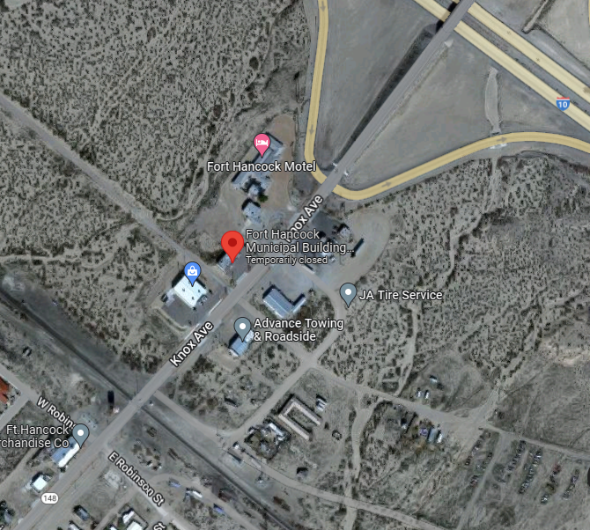

004 Dell City community Center 217 Main St.
Dell City, Tx.79837

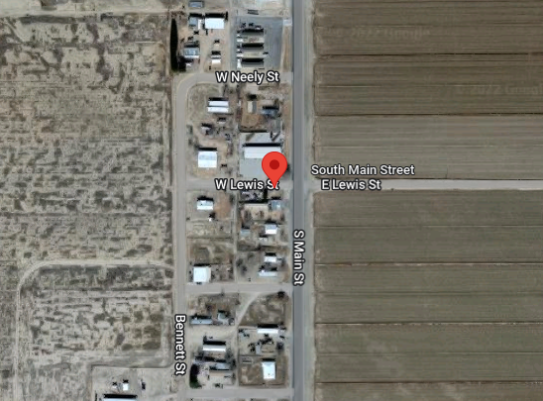

04NW Cornuda’s Café 84701 US Hwy 62/182
Cornudas, (Salt Flat) Tx 79847

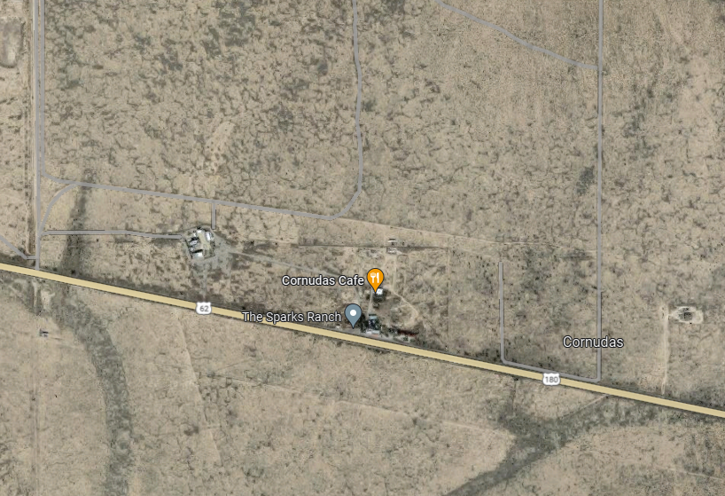

4S Church of Faith Hall Hwy. 111, Pat Ave.
Sierra Blanca, Tx 79851
